**CS504: Software Engineering**

**Programming Exercise 05**

**Step 1: Setup of the todos API**

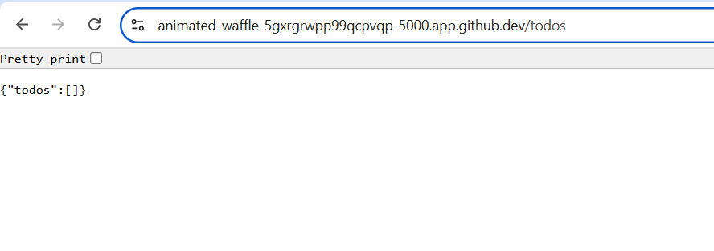

**Step 2: Testing the ‘todos’ Flask API on POST and GET Methods**

**Analysis:** A Flask API test includes setting the environment for a test in Python's unittest framework. This automated process allows functionality validation for several API endpoints, for example. In this setting, the tests will simulate HTTP requests to this API, such as GET and POST, and see if it returns appropriate responses. The set-up method in this code creates a test client. This is used to interact with an app instance without starting a real server. Individual tests, such as test_1_get_tasks_details or test_2_post_tasks_details, request a specific resource and then assert that the data returned matches the expected values. The payload variable will typically be JSON for sending data and requests to create or update resources. While running these tests, we ensure that the API is well-behaved, handles edge cases correctly, and returns correct responses for different conditions- contributing to the application's reliability.

**

**

**PE05 Answers**

1. **Why do we name the tests test_1, test_2, etc.?**

Naming the test functions with a prefix test_ is a Python convention in unit tests so that Python automatically recognizes test cases. A test runner will notice these functions and run them as tests. Naming tests sequentially, like test_1 and test_2, allows one to organize and run only certain specific tests in a more structured way. A better approach is to name tests concerning what they test, for example, test_create_task and test_get_task, for readability and maintainability of test suites with many tests.

1. **What is the purpose of the variable payload?**

In an API request, for example, the payload variable is the data sent with the request to the server. A POST typically contains creation or modification data for a resource in JSON format. The body will enable the client to pass what is required to the server, such as a new task in a to-do list API. It helps to send the necessary input data that will be processed and responded to by the server.

1. **What does the function assertEqual do?**

AssertionError is a method from the unittest framework for comparing two values as equal. When those values are not equal, that test will fail and generate an error message. This can be used for test cases of verification results where the actual output needs to match the expected output. The most common usage in tests of Web APIs is using assertEqual for response status code, response data, or any other critical value to confirm that the system behaves as expected.